**Software Requirements Specification Template**

The following annotated template shall be used to complete the Software Requirements Specification (SRS). The instructor must approve any modifications to the overall structure of this document.

**Template Usage:**

Text contained within angle brackets (‘<’, ‘>’) shall be replaced by your project-specific information and/or details. For example, <Project Name> will be replaced with either ‘Smart Home’ or ‘Sensor Network’.

Italicized text is included to briefly annotate the purpose of each section within this template. This text should not appear in the final version of your submitted SRS.

This cover page is not a part of the final template and should be removed before your SRS is submitted.

**Acknowledgements:**

Sections of this document are based upon the IEEE Guide to Software Requirements Specification (ANSI/IEEE Std. 830-1984).

<Project Name>

Software Requirements Specification

<Version>

<Date>

<Team member Name>

<Role>

*All members should be listed here

**Revision History**

|  |  |  |  |
| --- | --- | --- | --- |
| **Date** | **Description** | **Author** | **Comments** |
| <date> | <Version 1> | <Your Name> | <First Revision> |
|  |  |  |  |
|  |  |  |  |
|  |  |  |  |

**Document Approval**

The following Software Requirements Specification has been accepted and approved by the following:

|  |  |  |  |
| --- | --- | --- | --- |
| **Signature** | **Printed Name** | **Title** | **Date** |
|  |  |  |  |
|  |  |  |  |
|  |  |  |  |

**Table of Contents**

1. Introduction 1

1.1 Purpose 1

1.2 Scope 1

1.3 Definitions, Acronyms, and Abbreviations 1

1.4 Overview 1

2. General Description 1

2.1 Product Perspective 1

2.2 Product Functions 2

2.3 Users and Characteristics 2

2.4 General Constraints 2

2.5 Assumptions and Dependencies 2

2.6 Operating Environment 2

3. Specific Requirements 2

3.1 External Interface Requirements 3

3.1.1 User Interfaces 3

3.1.2 Hardware Interfaces 3

3.1.3 Software Interfaces 3

3.1.4 Communications Interfaces 3

3.2 Functional Requirements 3

3.2.1 <Functional Requirement or Feature #1> 3

3.2.2 <Functional Requirement or Feature #2> 3

3.3 Use Cases 4

3.3.1 Use Case #1 4

3.3.2 Use Case #2 4

3.4 Non-Functional Requirements 4

3.5.1 Performance 5

3.5.2 Reliability 5

3.5.3 Availability 5

3.5.4 Security 5

3.5.5 Maintainability 5

3.5.6 Portability 5

3.5 Design Constraints 5

3.6 Logical Database Requirements 5

3.7 Other Requirements 5

4. Analysis Models 5

4.1 Sequence Diagrams 6

5. Change Management Process 6

A. Appendices 6

A.1 Appendix 1 7

A.2 Appendix 2 7

**List of Figures**

Figure 1: Data Flow Diagram Example 1 6

Figure 2 Data Flow Diagram Example 2 6

**List of Tables**

Table 1: Use case 1 4

# 1. Introduction

<The introduction to the Software Requirement Specification (SRS) document should provide an overview of the complete SRS document. While writing this document please remember that this document should contain all of the information needed by a software engineer to adequately design and implement the software product described by the requirements listed in this document.>

## 1.1 Purpose

<What is the purpose of this SRS and the (intended) audience for which it is written?>

## 1.2 Scope

<This subsection should:

(1) Identify the software product(s) to be produced by name; for example, Host DBMS, Report Generator, etc.

(2) Explain what the software product(s) will, and, if necessary, will not do

(3) Describe the application of the software being specified. As a portion of this, it should:

(a) Describe all relevant benefits, objectives, and goals as precisely as possible. For example, to say that one goal is to provide effective reporting capabilities is not as good as saying parameter-driven, user-definable reports with a 2 hour turnaround and on-line entry of user parameters.

(b) Be consistent with similar statements in higher-level specifications (for example, the System Requirement Specification), if they exist. What is the scope of this software product?>

## 1.3 Definitions, Acronyms, and Abbreviations

<This subsection should provide the definitions of all terms, acronyms, and abbreviations required to properly interpret the SRS. This information may be provided by reference to one or more appendixes in the SRS or by reference to other documents.>

## 1.4 Overview

<This subsection should:

(1) Describe what the rest of the SRS contains

(2) Explain how the SRS is organized.>

# 2. General Description

<This section of the SRS should describe the general factors that affect the product and its requirements. This section does not state specific requirements; it only makes those requirements easier to understand.>

## 2.1 Product Perspective

<Describe the context and origin of the product being specified in this SRS. For example, state whether this product is a follow-on member of a product family, a replacement for certain existing systems, or a new, self-contained product. If the SRS defines a component of a larger system, relate the requirements of the larger system to the functionality of this software and identify interfaces between the two. A simple diagram that shows the major components of the overall system, subsystem interconnections, and external interfaces can be helpful.>

## 2.2 Product Functions

<Summarize the major functions the product must perform or must let the user perform. Details will be provided in Section 3, so only a high level summary (such as a bullet list) is needed here. Organize the functions to make them understandable to any reader of the SRS. A picture of the major groups of related requirements and how they relate is often effective.>

## 2.3 Users and Characteristics

<Identify the various user classes that you anticipate will use this product. User classes may be differentiated based on frequency of use, subset of product functions used, technical expertise, security or privilege levels, educational level, or experience. Describe the pertinent characteristics of each user class. Certain requirements may pertain only to certain user classes. Distinguish the most important user classes for this product from those who are less important to satisfy.>

## 2.4 General Constraints

<This subsection of the SRS should provide a general description of any other items that will limit the designer/developer’s options for designing/developing the system.>

## 2.5 Assumptions and Dependencies

<This subsection of the SRS should list each of the factors that affect the requirements stated in the SRS. These factors are not design constraints on the software but are, rather, any changes to them that can affect the requirements in the SRS. For example, an assumption might be that a specific operating system will be available on the hardware designated for the software product. If, in fact, the operating system is not available, the SRS would then have to change accordingly.>

## 2.6 Operating Environment

<Describe the environment in which the software will operate, including the hardware platform, operating system and versions, and any other software components or applications with which it must peacefully coexist.>

# 3. Specific Requirements

<This will be the largest and most important section of the SRS. The customer requirements are embodied within Section 2 (functions), but this section will give the D-requirements that are used to guide the project’s software design, implementation, and testing.

Each requirement in this section should be:

* Correct
* Traceable (both forward and backward to prior/future artifacts)
* Unambiguous
* Verifiable (i.e., testable)
* Prioritized (with respect to importance and/or stability)
* Complete
* Consistent (with other requirements)
* Uniquely identifiable (usually via numbering like 3.4.5.6)

Attention should be paid to the carefully organize the requirements presented in this section so that they may easily accessed and understood. Furthermore, this SRS is not the software design document, therefore one should avoid the tendency to over-constrain (and therefore design) the software project within this SRS.>

## 3.1 External Interface Requirements

### 3.1.1 User Interfaces

### 3.1.2 Hardware Interfaces

### 3.1.3 Software Interfaces

### 3.1.4 Communications Interfaces

## 3.2 Functional Requirements

This section describes specific features of the software project. If desired, some requirements may be specified in the use-case format and listed in the Use Cases Section.

### 3.2.1 <Functional Requirement or Feature #1>

<Don’t use “System Feature 1.” State the feature name in just a few words.>

#### 3.2.1.1 Description and Priority

<Provide a short description of the feature and indicate whether it is of High, Medium, or Low priority. You could also include specific priority component ratings, such as benefit, penalty, cost, and risk (each rated on a relative scale from a low of 1 to a high of 9).>

#### 3.2.1.2 Stimulus/Response Sequences

<List the sequences of user actions and system responses that stimulate the behavior defined for this feature. These will correspond to the dialog elements associated with use cases.>

#### 3.2.1.3 Functional Requirements

<Itemize the detailed functional requirements associated with this feature. These are the software capabilities that must be present in order for the user to carry out the services provided by the feature, or to execute the use case. Include how the product should respond to anticipated error conditions or invalid inputs. Requirements should be concise, complete, unambiguous, verifiable, and necessary. Use “TBD” as a placeholder to indicate when necessary information is not yet available.>

*<Each requirement should be uniquely identified with a sequence number or a meaningful tag of some kind.>*

##### 3.2.1.3.1 REQ-1: <Example, for the ATM Machine withdraw cash feature, the visual interface has to be working for the user to be able to enter information>

##### 3.2.1.3.2 REQ-2:

…….

### 3.2.2 <Functional Requirement or Feature #2>

…

…

## 3.3 Use Cases

### 3.3.1 Use Case #1

|  |  |
| --- | --- |
| **Use Case Name** | Search Article |
| **Reference** | Section 2.2.1, Section 7.1 |
| **Trigger** | The Reader assesses the Online Journal Website |
| **Precondition** | The Web is displayed with grids for searching |
| **Basic Path** | 1. The Reader chooses how to search the Web site. The choices are by Author, by Category, and by Keyword. 2. If the search is by Author, the system creates and presents an alphabetical list of all authors in the database. In the case of an article with multiple authors, each is contained in the list. 3. The Reader selects an author. 4. The system creates and presents a list of all articles by that author in the database. 5. The Reader selects an article. 6. The system displays the Abstract for the article. 7. The Reader selects to download the article or to return to the article list or to the previous list. |
| **Alternative Paths** | In step 2, if the Reader selects to search by category, the system creates and presents a list of all categories in the database.   1. The Reader selects a category. 2. The system creates and presents a list of all articles in that category in the database. Return to step 5.   In step 2, if the Reader selects to search by keyword, the system presents a dialog box to enter the keyword or phrase.   1. The Reader enters a keyword or phrase. 2. The system searches the Abstracts for all articles with that keyword or phrase and creates and presents a list of all such articles in the database. Return to step 5. |
| **Postcondition** | The selected article is downloaded to the client machine. |
| **Exception Paths** | The Reader may abandon the search at any time. |
| **Other** | The categories list is generated from the information provided when article are published and not predefined in the Online Journal database. |

Table 1: Use case 1

### 3.3.2 Use Case #2

…

## 3.4 Non-Functional Requirements

Non-functional requirements may exist for the following attributes. Often these requirements must be achieved at a system-wide level rather than at a unit level. State the requirements in the following sections in measurable terms (e.g., 95% of transaction shall be processed in less than a second, system downtime may not exceed 1 minute per day, > 30 day MTBF value, etc.).

### 3.5.1 Performance

### 3.5.2 Reliability

### 3.5.3 Availability

### 3.5.4 Security

<Example: The server on which the Online Journal resides will have its own security to prevent unauthorized *write*/*delete* access. There is no restriction on *read* access. The use of email by an Author or Reviewer is on the client systems and thus is external to the system. The PC on which the Article Manager resides will have its own security. Only the Editor will have physical access to the machine and the program on it. There is no special protection built into this system other than to provide the editor with *write* access to the Online Journal to publish an article.>

### 3.5.5 Maintainability

### 3.5.6 Portability

## 3.5 Design Constraints

<Specify design constrains imposed by other standards, company policies, hardware limitation, etc. that will impact this software project. Example, the software is required to have a login screen based on company policies.>

## 3.6 Logical Database Requirements

<Will a database be used? If so, what logical requirements exist for data formats, storage capabilities, data retention, data integrity, etc?>

## 3.7 Other Requirements

<Catchall section for any additional requirements that did not belong to the previous sections. If there are none, exclude this section>

# 4. Analysis Models

<List all analysis models used in developing specific requirements previously given in this SRS. Each model should include an introduction and a narrative description. Furthermore, each model should be traceable the SRS’s requirements.>

## Sequence Diagrams

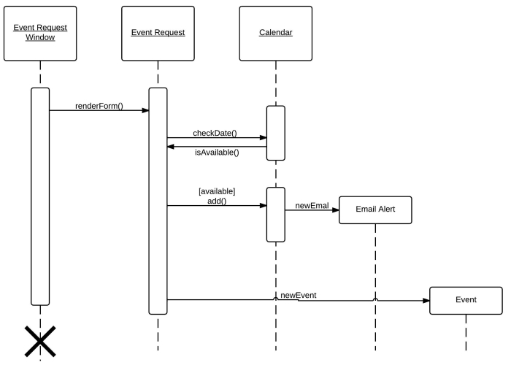

Figure 1: Data Flow Diagram Example 1

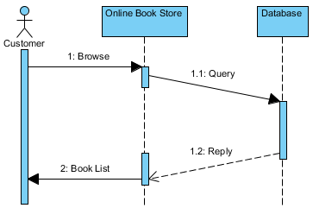

Figure 2 Data Flow Diagram Example 2

<At least one sequence diagram should be included for each requirement or use case.>

# 5. Change Management Process

<Identify and describe the process that will be used to update the SRS, as needed, when project scope or requirements change. Who can submit changes and by what means, and how will these changes be approved.>

# References

# Appendices

<Appendices may be used to provide additional (and hopefully helpful) information. If present, the SRS should explicitly state whether the information contained within an appendix is to be considered as a part of the SRS’s overall set of requirements. Example Appendices could include (initial) conceptual documents for the software project, marketing materials, minutes of meetings with the customer(s), etc.>

## A.1 Appendix 1

## A.2 Appendix 2